Online Registration Process
  - Help Guide for Businesses and Other Organisations
Contents
About This Guide 2
Getting Started 2
Introduction 3
Organisation Details 4
Contact 5
Offer Details 6
Disciplines 7
Locations 8
Opportunities 10
Final Step 12

About This Guide
- This guide is intended to assist businesses and other organisations in completing the online registration process for the New Colombo Plan Internship and Mentorship Network.

Getting Started
The registration process should take no longer than 10 minutes to complete. Please complete the process in its entirety before submitting your registration. Mandatory fields are indicated in red. If you have any trouble accessing this site, please contact the New Colombo Plan Secretariat at +612 6261 9840 or ncp.business@dfat.gov.au.
Please note that the registration form will time-out after 20 minutes of inactivity.
- On the main page click Register to launch the registration process.

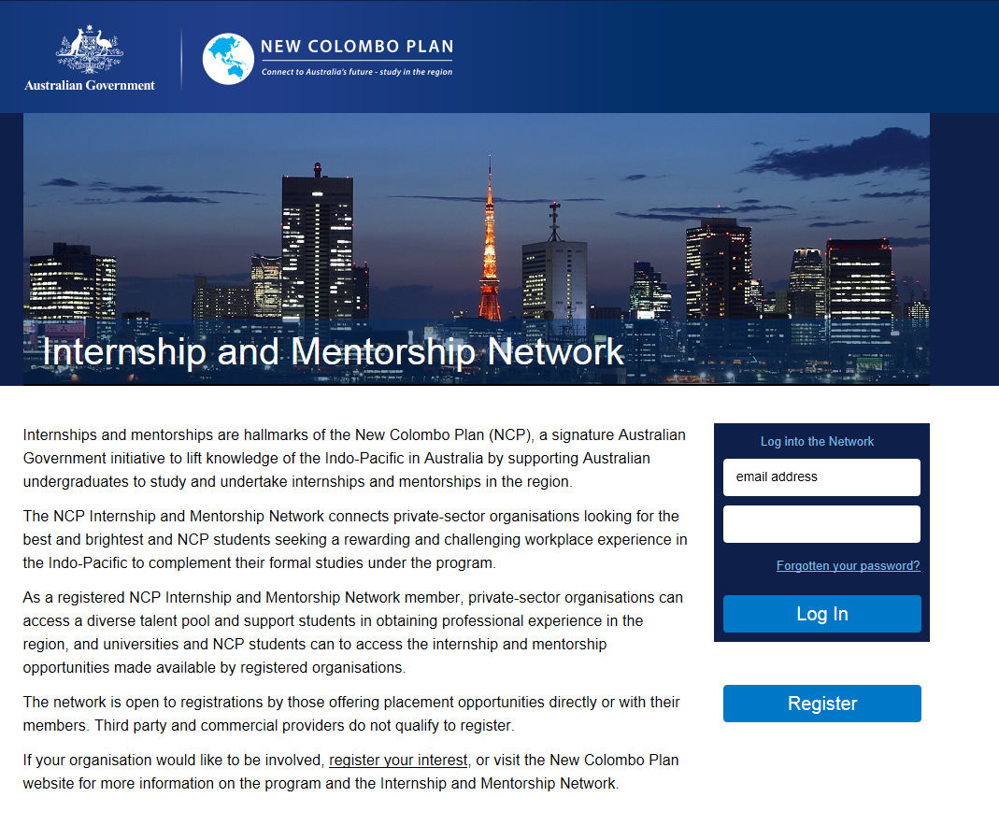

Introduction
This is the introductory step and includes information about the online network and how you can present the opportunities that you wish to offer New Colombo Plan students.
We hope that you find useful the range of options for registering workplace opportunities to New Colombo Plan students. You can submit opportunities in a variety of ways:
- registering specific opportunities according to location, discipline and timeframe – this allows organisations to target student cohorts that interest them
- registering a broad range of opportunities or interests – this allows organisations to attract a variety of interest from universities and students.
Organisations that are registering to use the online network for the first time are required to acknowledge that they have read and accepted the website’s terms and conditions, which are available on this page.
- Read and accept the terms of use before proceeding to the registration form.

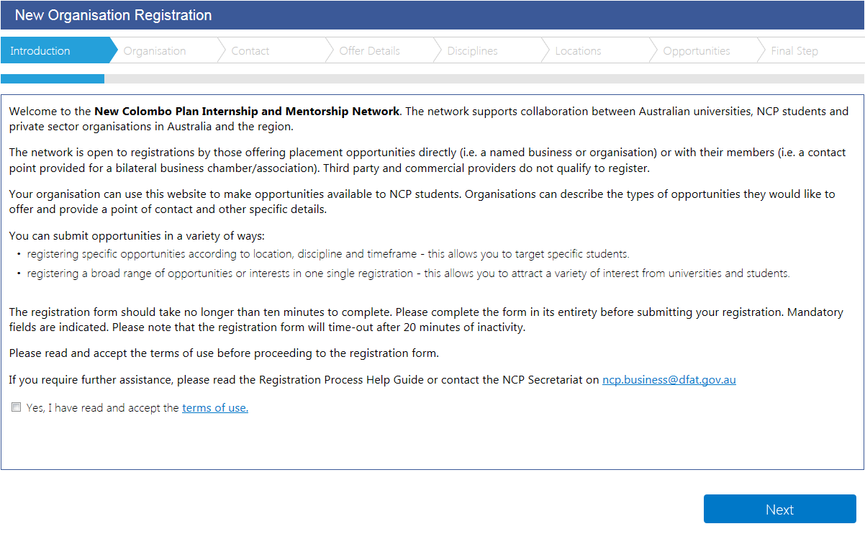
– Organisation page

Organisation Details
At this step, you can submit information to promote your organisation to Australian universities and their students receiving New Colombo Plan awards. All information included on the form, including free text contributions, will be listed on the online network and made available to Australian universities and students to review. You can also include a link to your external website, if you wish to do so.
- Enter your organisation name.
- Provide a brief description of your organisation.
- Enter your website address.

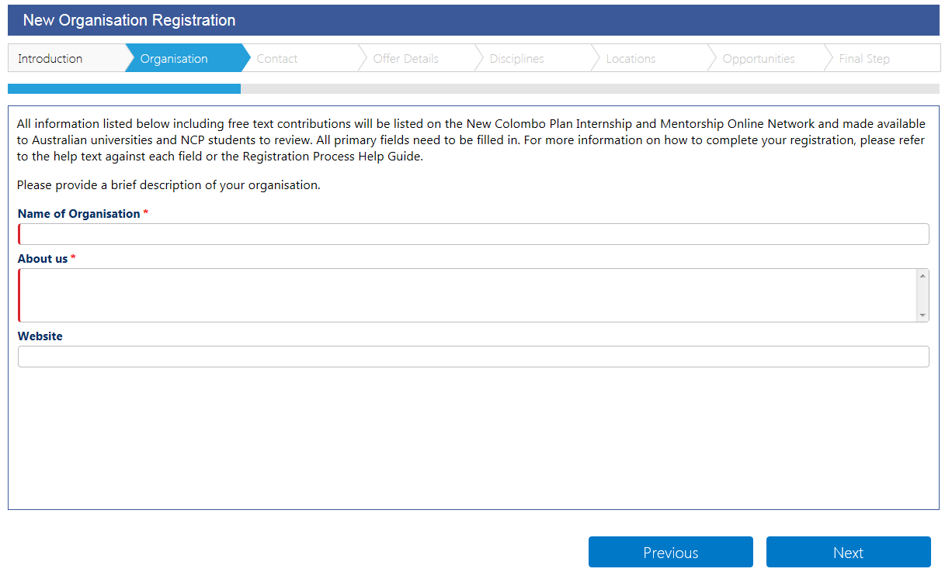
– Contact page
– Introduction page

Contact
At this step, you can provide a contact point to enable Australian universities and students to contact your organisation directly to enquire about the opportunities that you post on the online network.
Note: The personal information that you submit via this website will be published on the website and will be accessible by Australian universities, New Colombo Plan students and by the Australian Government’s Support Services Organisation for New Colombo Plan students to assist with the implementation of work placement arrangements.
- Enter your first name and last name.
- Enter your position.
- Provide your email address.
Note: This email address will be used to log in to the website.

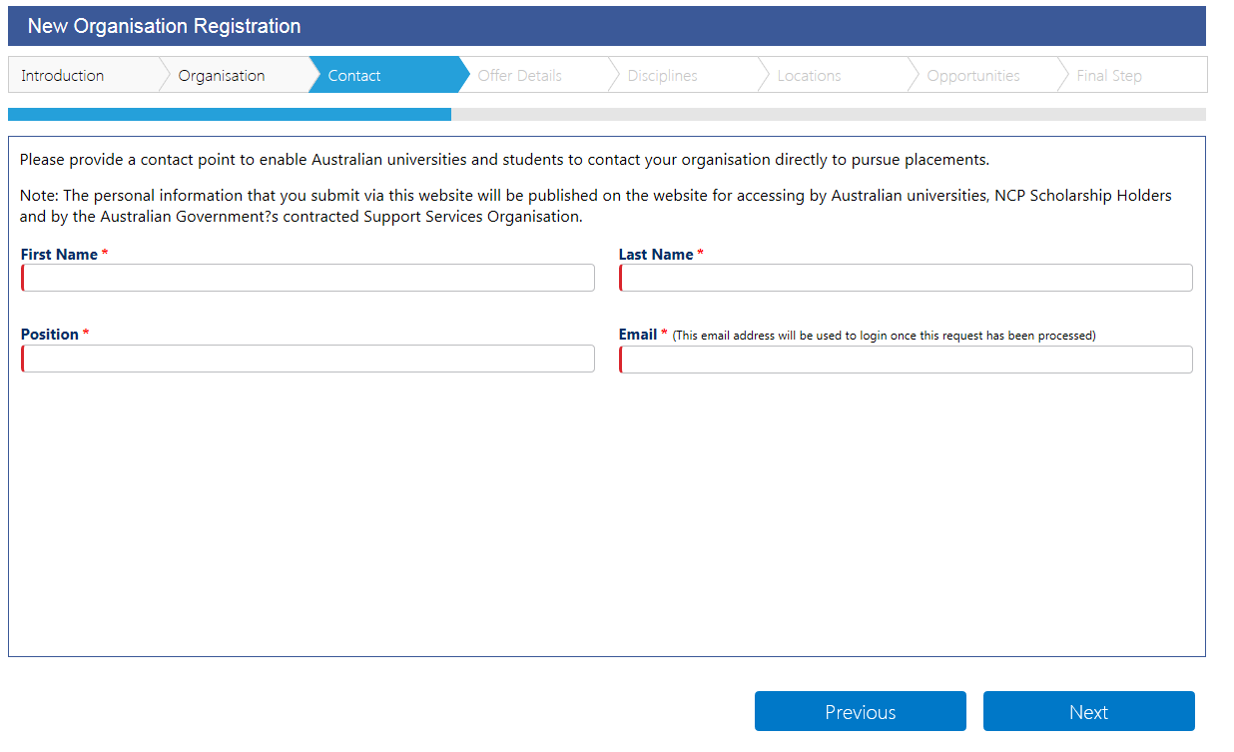
– Offer Details page
– Organisation page

Offer Details
You can use this page to provide details of placement opportunities you wish to offer to New Colombo Plan students.
Please use the drop down menus to select the details of placements that you would like to offer, noting that multiple fields can be selected. This will help you target students of most interest to your organisation. Help text is provided to guide you through the menus. If the type of opportunity that you wish to offer is not listed in the drop down menus, please specify in the space provided.
- Select the opportunity types you wish to offer to New Colombo Plan students.
- The length of opportunities is up to you and can vary depending on your preference.
- Select the placement types.
- Select the compensation types. Under New Colombo Plan guidelines, there is no requirement to pay students undertaking placements but your organisation may wish to offer compensation.

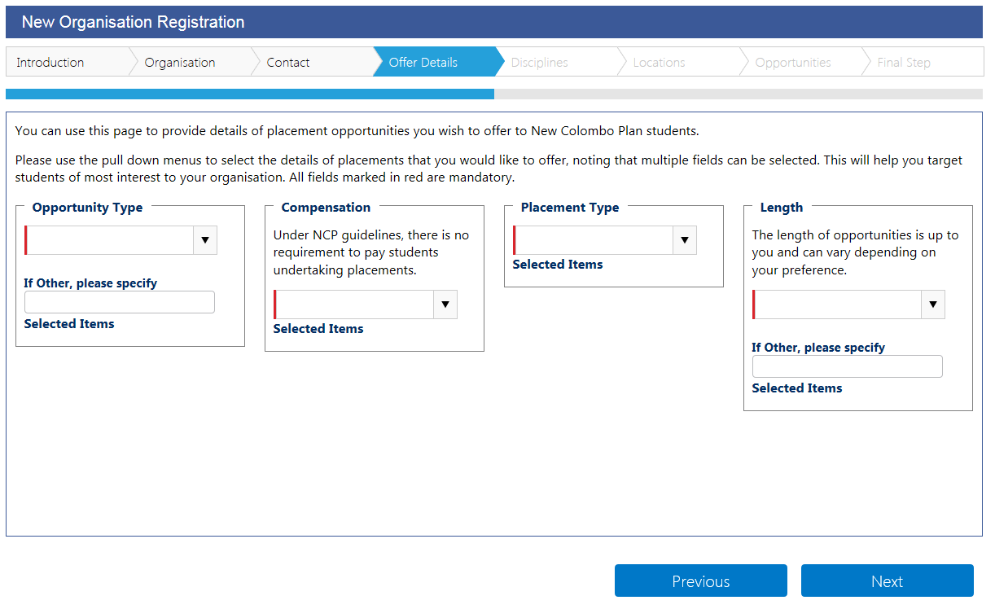
– Disciplines page
– Contact page

Disciplines
You can use this page to target students undertaking studies in a particular academic discipline, as relevant to the opportunity that you are offering. Australian students from all academic disciplines participate in the New Colombo Plan. If your organisation is interested in hosting a student from one or more specific academic disciplines, please select multiple options from the drop down menu below. If the discipline you want to target is not listed, please specify in the space provided.
- Select one or more disciplines.

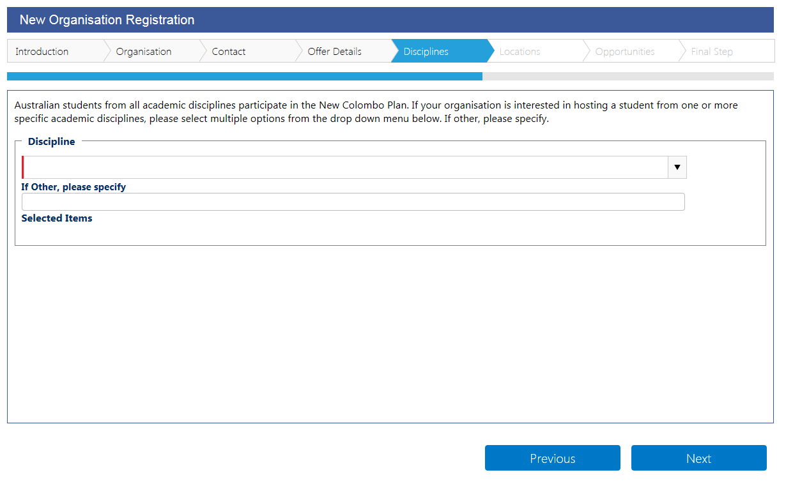
– Locations page
– Offer Details page

Locations
You can make offers at a single location or offer placements at multiple locations, as best suits your organisation.
- Click Add Location to add a location including city. To add multiple locations, repeat this step.

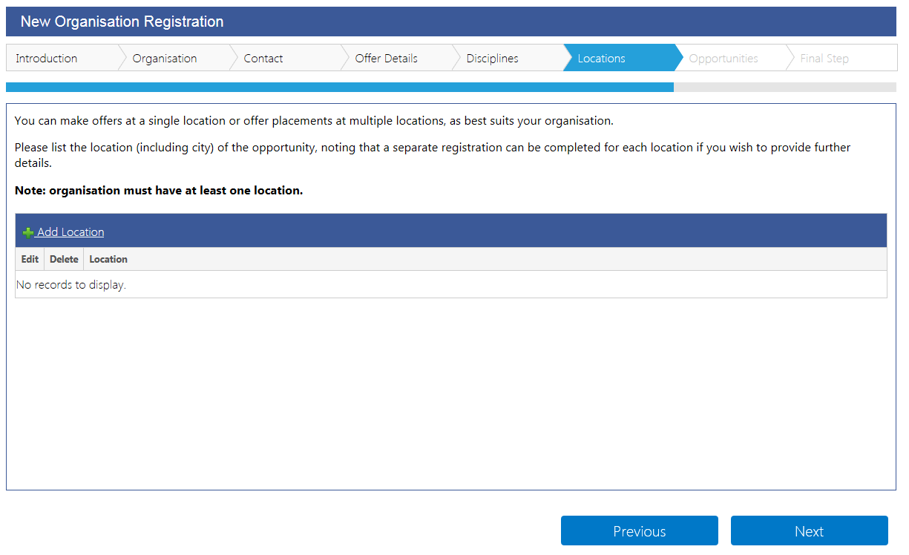
- Select a location from the drop down menu.
- Enter the city.
- Click Update when done.
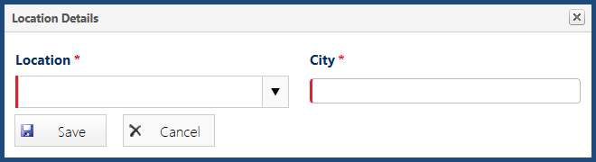
– Opportunities page
– Disciplines page

Opportunities
Further to the offer details you have entered, this page allows you to enter details of specific opportunities or other requirements you wish to draw to the attention of New Colombo Plan students. For example, your may wish to enter details of required language skills, a date range for specific opportunities or direct students to an external website containing further information on work place programs offered by your organisation.
Note: Completing this page is not mandatory if you consider that the information you provided under the ‘Offer Details’ step is sufficient.
- Click Add Opportunity to enter details of specific opportunities. To add multiple entries, repeat this step.

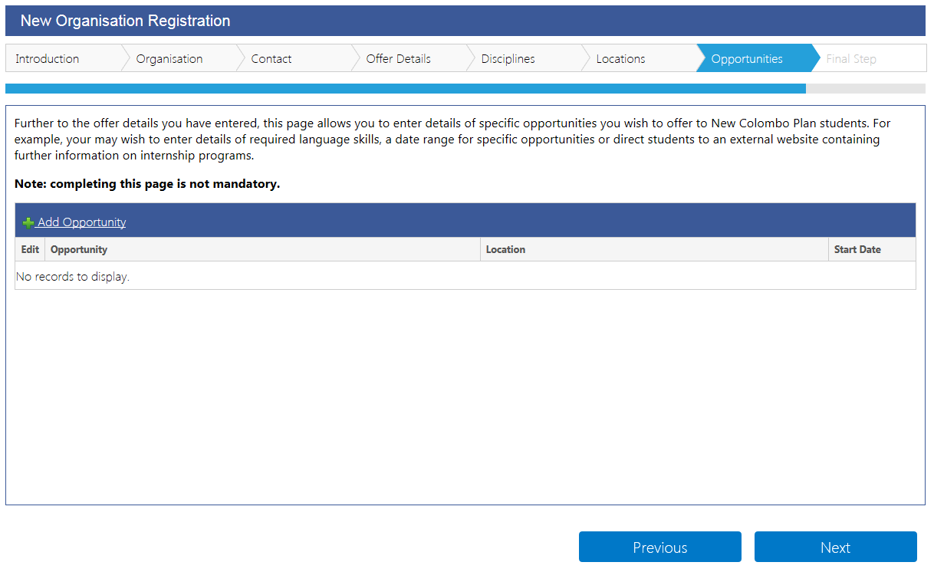
- Provide a brief description about the specific opportunity you wish to offer.
- Select the opportunity type, location, including city, and a point of contact.
- Provide other details about this specific opportunity, as considered appropriate.
- Click Save when done.
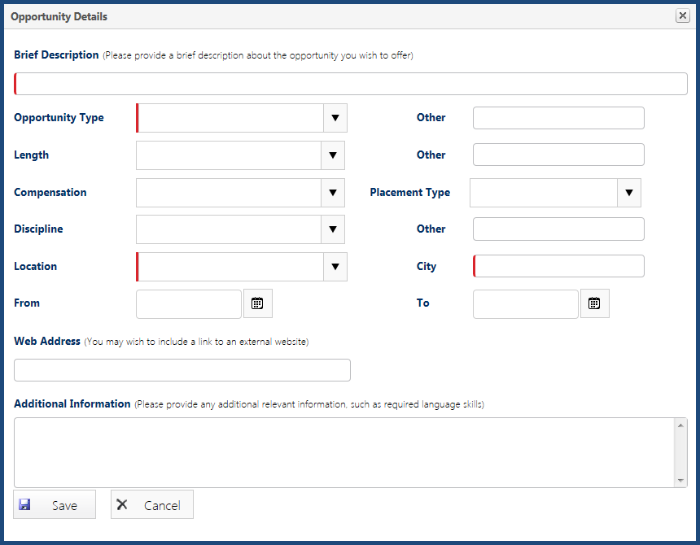
– Final Step
– Locations page

Final Step
This is the final step of the registration process.
The information you submitted via the online registration process will be processed by the New Colombo Plan Secretariat to enable it to be included on the website.
Subject to the success of your registration, we will send you an email with instructions on how to log into the website to view your organisation’s listing.
We will also provide instructions on how you can upload your organisation’s logo on the website.
The New Colombo Plan Secretariat does not arrange the individual work placements offered by your organisation. Students or universities interested in an opportunity offered by your organisation will contact your nominated contact person. The arrangements for a specific work placement are settled directly between your organisation and the accepting student and their university.
For further assistance please contact the New Colombo Plan Secretariat on +612 6261 9840 or ncp.business@dfat.gov.au.
- Click Submit Registration to submit your registration.

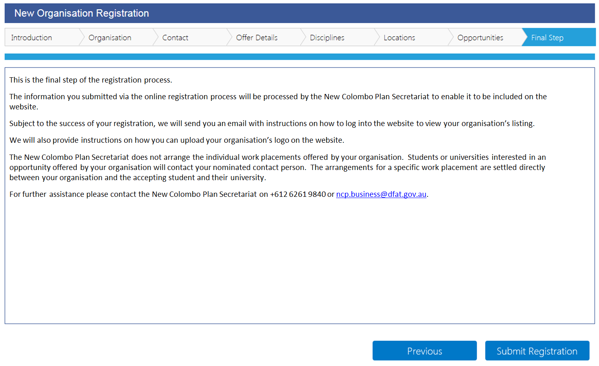
– Opportunities page
– Submit registration

